

AI Driven SQA: Manual & Automation Testing

Assignment 05

Module: 05
Topic: Problem Solving with AI (Claude Code + JavaScript)

Submitted by,
Name: Jhion Adbar Opi
Batch: 21
Phone: 01778812373
Q1. JavaScript Coding Practice.

01. Convert Celsius to Fahrenheit.
Answer: The program accepts a Celsius temperature from the user through the Node.js command-line interface. Convert the input into a numerical value. Applies the Celsius-to-Fahrenheit conversion formula and displays the resulting Fahrenheit temperature.

Output:
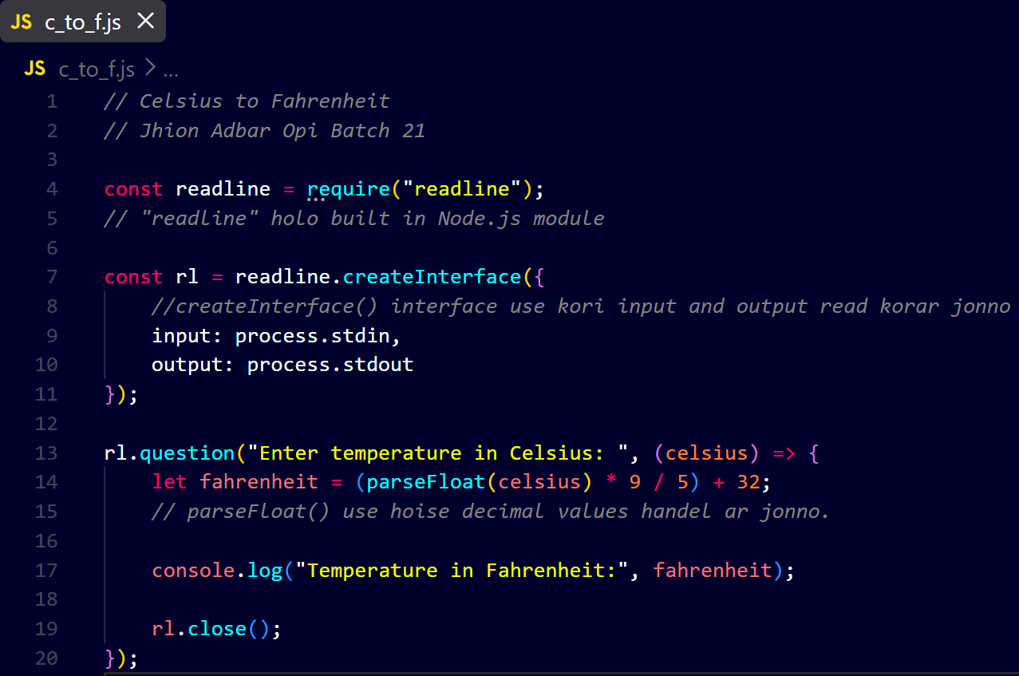
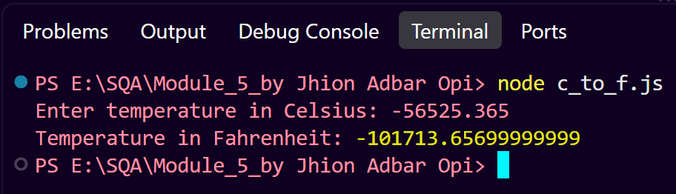

Source Code: https://drive.google.com/drive/folders/1gZiRwN0ktX8Zn8BDXpPTg4JLdlr_5CZI?usp=sharing

Explanation:
[ readline ] Module: The program imports Node.js's built-in [ readline ] module using require(). This module is used to receive input from the user through the command-line interface.

Creating the [ readline ] Interface: [ readline.createInterface() ] creates an interface for handling input and output. [ process.stdin ] is used to receive input from the keyboard. While [ process.stdout ] is used to display output in the terminal.

Taking User Input: The [ rl.question() ] method prompts the user to enter a temperature in Celsius. The entered value is received by the callback function through the [ celsius ] parameter.

Converting Input to a Number: Since command-line input is received as a string. [ parseFloat() ] converts the input into a floating-point number. This allows the program to handle positive, negative and decimal temperature values.

Temperature Conversion: The program converts Celsius to Fahrenheit using the formula:
F= (C x (9/5))+32
The calculated value is stored in the [ fahrenheit ] variable.

Displaying the Result: [ console.log() ] displays the converted Fahrenheit temperature in the terminal.

Closing the Interface: [ rl.close() ] closes the [ readline ] interface and terminates the input operation. Allowing the program to exit properly.

02. Find the Factorial of a Number.
Answer: The program uses a user-defined function and an iterative for loop to calculate the factorial of a non-negative integer. User input is collected using Node.js's [ readline ] module and converted into an integer using [ parseInt() ]. The program validates the input and calculates the factorial through repeated multiplication. Then displays the result and finally closes the [ readline ] interface.

Output:
// Find the Factorial of a Number
// Jhion Adbar Opi Batch 21

const readline = require("readline");

const rl = readline.createInterface({
input: process.stdin, // receive input
output: process.stdout // display output in terminal
});

function factorial(n) {
let result = 1;

for (let i = 1; i <= n; i++) {
result = result * i;
}

return result;
}

rl.question("Enter a non-negative integer: ", (input) => {

let number = parseInt(input);

if (number < 0 || isNaN(number)) {
console.log("Please enter a valid non-negative integer.");
} else {
let result = factorial(number);
console.log("Factorial of", number, "is:", result);
}

rl.close();
});

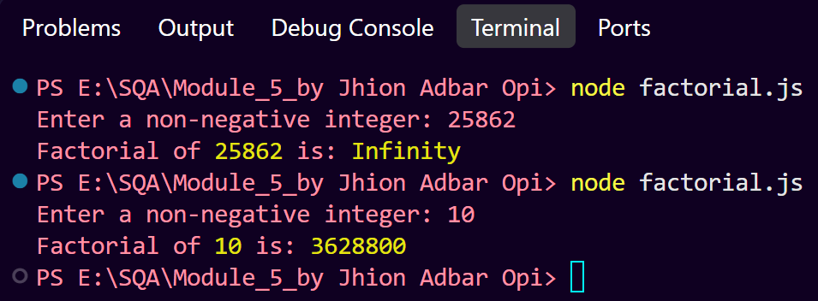
Source Code: https://drive.google.com/drive/folders/1uAnVFZ81YPQ4Qr0Q5gncjpj9zt96wA7T?usp=drive_link

Explanation:
Importing the [ readline ] Module: The program imports Node.js's built-in readline module to receive input from the user through the command-line interface.

Creating the [ readline ] Interface: [ readline.createInterface() ] creates an interface for handling input and output. [ process.stdin ] receives input from the keyboard. While [ process.stdout ] displays output in the terminal.

Defining the Factorial Function: The factorial(n) function is created to calculate the factorial of the given number. The parameter n represents the input number.

Initializing the Result: The variable result is initialized with 1. This is necessary because factorial multiplication starts with 1.

Using a For Loop: A for loop iterates from 1 to the given number. During each iteration, the current value of i is multiplied with result.
result = result * i;

Returning the Factorial: After the loop completes, the calculated factorial is returned using the return statement.

Taking User Input: The [ rl.question()] method asks the user to enter a non-negative integer. The input is initially received as a string.

Converting Input to an Integer: [ parseInt() ] converts the user's input from a string into an integer so that mathematical operations can be performed.

Input Validation: The program checks whether the entered value is negative or invalid using:
if (number < 0 || isNaN(number))

Factorial is defined for non-negative integers, so negative or invalid input is rejected.

Calling the Function: If the input is valid. The factorial() function is called with the user's number and the returned result is stored in the result variable.

Displaying the Result: [ console.log() ] displays the calculated factorial in the terminal.

Closing the Interface: [ rl.close() ] closes the [ readline ] interface after the program finishes processing the input.
03. Check for Palindrome.
Answer: The program uses a user-defined function to determine whether a given word is a palindrome. The input string is converted into an array of characters using split(), reversed using reverse() and converted back into a string using join(). The reversed string is then compared with the original string using the strict equality operator [ === ]. The function returns a Boolean value [ true ] for a palindrome and [ false ] otherwise.

Output:
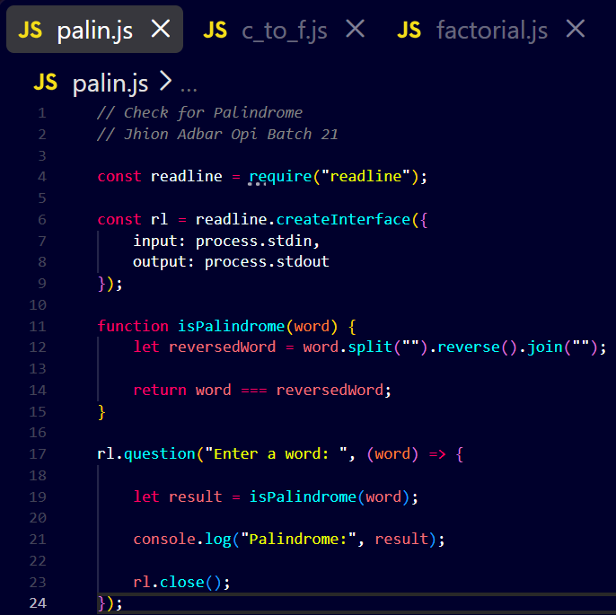

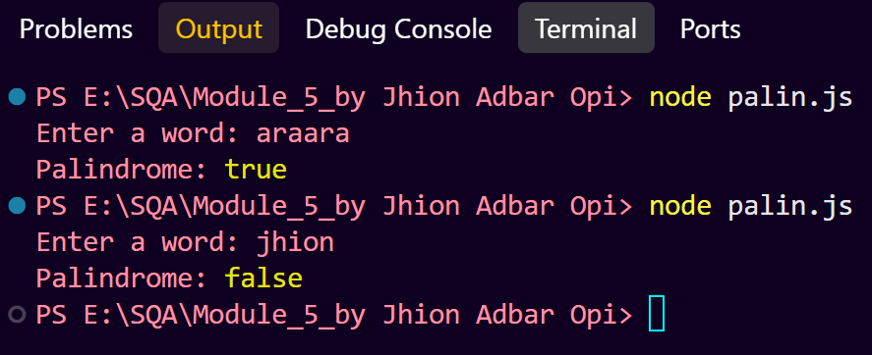
Source Code: https://drive.google.com/drive/folders/1GtAuIIM3O1ZAMKazwZncpA-UDNuvGGtE?usp=drive_link

Explanation:
Importing the [ readline ] Module: The program imports Node.js's built-in [ readline ] module to receive input from the user through the command-line interface.

Creating the [ readline ] Interface: [ readline.createInterface() ] creates an interface for handling input and output. [ process.stdin ] receives keyboard input, while [ process.stdout ] displays output in the terminal.

Defining the Palindrome Function: The [ isPalindrome(word) ] function is created to determine whether the given word is a palindrome. The [ word ] is passed to the function through the word parameter.

Splitting the String: The [ split("") ] method separates the string into individual characters.
Output we get : "araara" => ["a", "r", "a", "a", "r", "a"]

Reversing the Characters: The [ reverse() ] method reverses the order of the characters.
["a", "r", "a", "a", "r", "a"] => ["a", "r", "a", "a", "r", "a"]
In the case of [ araara ], the reversed word is identical to the original word.

Joining the Characters: The [ join("") ] method combines the individual characters back into a single string.
[ word.split("").reverse().join(""); ] This produces the reversed version of the original word.

Comparing the Original and Reversed Words: The program uses the strict equality operator [ === ]:
[ return word === reversedWord; ]
If both strings are identical, the function returns true. Otherwise, it returns false.

Taking User Input: The [ rl.question() ] method asks the user to enter a word. The entered word is passed to the callback function through the word parameter.

Calling the Function: The [ isPalindrome() ] function is called with the user's input, and the returned Boolean value is stored in the result variable.

Displaying the Result: [ console.log() ] displays whether the entered word is a palindrome.

Closing the [ readline ] Interface: [ rl.close() ] closes the [ readline ] interface after the program finishes processing the input.
04. Sum of Array Elements.
Answer: The program accepts multiple numerical values from the user, converts the input into an array of numbers and passes the array to a user-defined function. The function uses a for loop to iterate through each array element and accumulates their values in a sum variable. Then the function returns the total sum. Which is displayed in the terminal.

Output:
// Sum of Array Elements
// Jhion Adbar Opi Batch 21

const readline = require("readline");

const rl = readline.createInterface({
input: process.stdin,
output: process.stdout
});

function sumArray(numbers) {
let sum = 0;

for (let i = 0; i < numbers.length; i++) {
sum = sum + numbers[i];
}

return sum;
}

rl.question("Enter numbers separated by spaces: ", (input) => {

let numbers = input.split(" ").map(Number);

let result = sumArray(numbers);

console.log("Sum of array elements:", result);

rl.close();
});
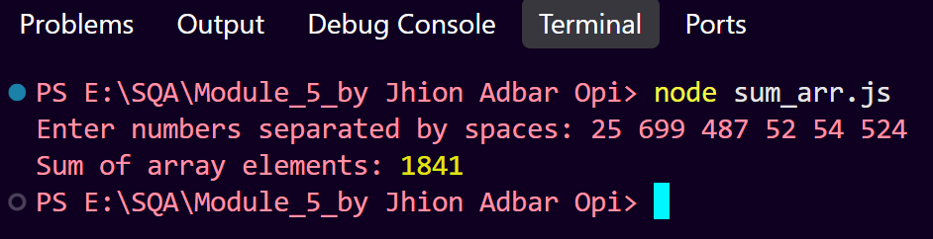

Source Code:
https://drive.google.com/drive/folders/1mVnF9m8JtIYYKphjtMMbCJ_t3K-LM6of?usp=drive_link

Explanation:
Importing the [ readline ] Module: The program imports Node.js's built-in [ readline ] module to receive input from the user through the command-line interface.

Creating the [ readline ] Interface: [ readline.createInterface() ] creates an interface for handling input and output. [ process.stdin ] receives input from the keyboard. While [ process.stdout ] displays output in the terminal.

Defining the Function: The [ sumArray(numbers) ] function is created to calculate the sum of all elements in an array. The array is passed to the function through the [ numbers ] parameter.

Initializing the Sum: The variable sum is initialized to 0. [ let sum = 0; ]. Starting with zero allows each array element to be added to the accumulated total.

Iterating Through the Array: A for loop is used to access each element of the array.
for (let i = 0; i < numbers.length; i++)

The loop starts from index 0 and continues until it reaches the last element of the array.

Adding Array Elements: Each element is added to the sum variable:
sum = sum + numbers[i];

The value of sum is updated during every iteration.

Returning the Result: After all elements have been processed the [ return ] statement returns the calculated sum.

Taking User Input: The [ rl.question() ] method asks the user to enter numbers separated by spaces.
Given Output:
Enter numbers separated by spaces: 10 20 30 40

Converting Input into an Array: The [ split(" ") ] method separates the input string at each space.
input.split(" ")
This produces:
["10", "20", "30", "40"]

Converting Strings to Numbers: The [ map(Number) ] method converts each string element into a numerical value.
.map(Number)
Therefore:
["10", "20", "30", "40"]
becomes:
[10, 20, 30, 40]

Calling the Function: The [ sumArray() ] function is called with the converted array, and the returned value is stored in the result variable.

Displaying the Result: [ console.log() ] displays the calculated sum in the terminal.

Closing the Interface: [ rl.close() ] closes the [ readline ] interface after the program finishes processing the input.
05. FizzBuzz (Basic).
Answer: The program implements a flexible FizzBuzz algorithm using Node.js and user-defined input. The user provides a starting number and the desired sequence length. A for loop then processes exactly the specified number of consecutive integers. The modulus operator (%) determines divisibility by 3 and 5. While conditional statements produce [ Fizz, Buzz, FizzBuzz ] or the original number accordingly. This approach makes the basic FizzBuzz problem reusable for different starting values and sequence lengths.

Code:
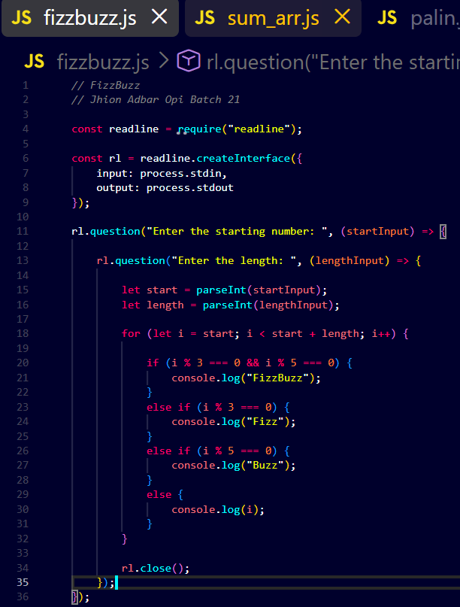

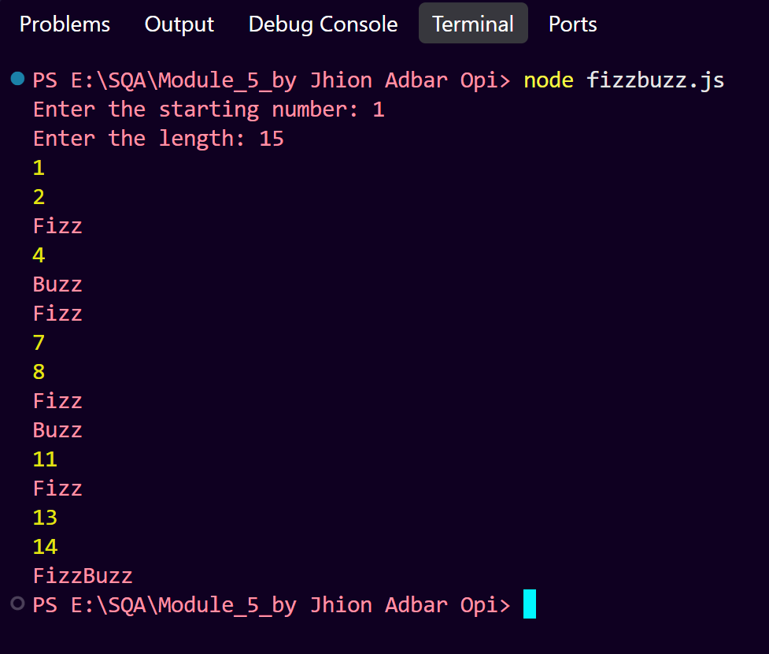
Output:

Source Code:
https://drive.google.com/drive/folders/1B9Ce1Yr3iwSFmcBZMj-sq9Uh8qB02owk?usp=drive_link

Explanation:
Taking the Starting Number: The program asks the user to provide the starting number. This value determines where the FizzBuzz sequence begins.

Taking the Length: The program also asks the user to enter the length of the sequence. The length determines how many numbers will be processed.

Converting Input to Integers: [ parseInt() ] converts the input received from the [ readline ] interface from strings into integer values.

Controlling the Loop: The for loop starts from the user-provided start value and executes for the specified length.
for (let i = start; i < start + length; i++)

The condition [ i < start + length ] ensures that exactly the requested number of values is processed.

Checking Divisibility by Both Numbers: The first condition checks whether the current number is divisible by both 3 and 5.
i % 3 === 0 && i % 5 === 0

If both conditions are true, the program prints [ FizzBuzz ].

Checking Divisibility by 3: If the number is not divisible by both. The program checks whether it is divisible by 3. If true, it prints [ Fizz ].

Checking Divisibility by 5: If the number is not divisible by 3. The program checks whether it is divisible by 5. If true, it prints [ Buzz ].

Printing the Original Number: If none of the divisibility conditions are satisfied. The original number is printed.

Closing the Interface: [ rl.close() ] closes the [ readline ] interface after the loop has completed.

